Aligarh Muslim University
Department of Computer Science

LAB FILE


Submitted By:
Name: Sumaniya Sheikh
Enrolment Number: GR0960
Faculty Number: 25CAMSA144
Subject Code: CAMS3P01
Subject Name: Laboratory Course -III
Submitted To:
Dr. Faisal Anwer
Dr. Faraz Masood
Mr. Saad Shamim
Mr. Ahsan Shameem

Week #1
- Write a program to find the product of two user-supplied integers and if the product is equal to or lower than 5000, then return the sum of the two numbers.

Solution:
num1,num2= int(input("enter a number = ")),int(input("enter a number = "));
print(num1+num2 if num1*num2<=5000 else prod)
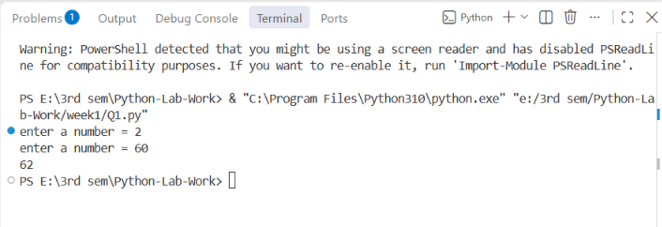
- Write a program to print the sum of the first 10 numbers

Solution:
for i in range(1, 11):
sum=sum+i
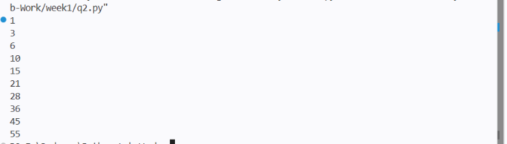
print(sum)
- Write a program to iterate through a supplied list of 20 numbers and print only those numbers which are divisible by 5.

Solution:
num=[1,2,3,4,5,6,7,8,9,10,11,12,13,14,30,24,34,32,27,35]
for i in num:
if i%5==0:
print(i)
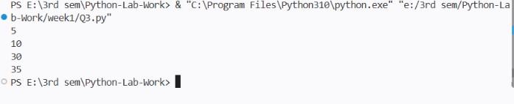
- Write a program to check if the given number is a palindrome.

Solution:
num=(input("enter a number = "))
if str(num)==str(num)[::-1]:
print("palindrome")
else:
print("not palindrome")
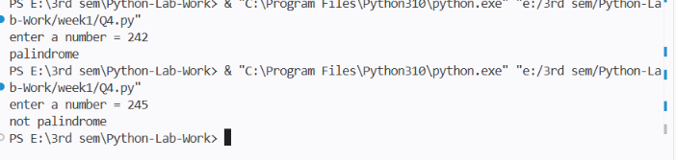
- Write a program to calculate the cube of all numbers from 1 to a given number.

Solution:
num=int(input("enter a three digit number = "))
for i in range(1, num):
cube=i*i*i
print(cube)
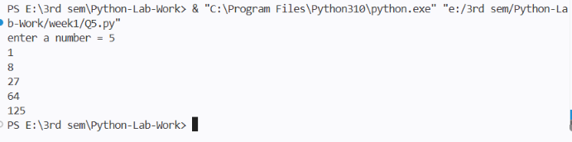

Week #2
- Write a program to extract each digit from an integer in reverse order.
Solution:
num=int(input("enter number = "))
while num>0:
digit= num%10
print(digit)
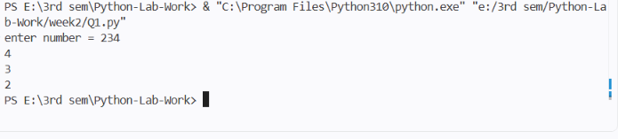
num=num//10
- Write a program to count the total number of digits in a number using a while loop.

Solution:
num=int(input("enter number = "))
count=0
while num>0:
digit= num%10
count=count+1
num=num//10

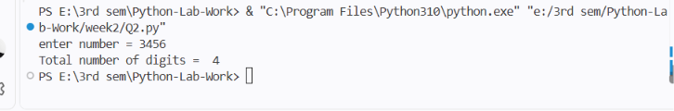
print("Total number of digits = ", count)
- Write a program to display all prime numbers within a range.

Solution:
start=int(input("enter the starting number = "))
end=int(input("enter the end range = "))
for num in range(start, end+1):
if num<2:
continue
is_prime =True
for i in range(2, int(num ** 0.5)+1):
if num%i==0:
is_prime=False
break
if is_prime:
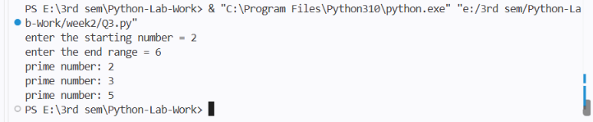
print(num)
- Write a program to use a loop to find the factorial of a given number.

Solution:
from functools import reduce;
n=int(input("enter a number = ")); fact=(reduce(lambda x,y: x*y, range(1,n+1),1))
print(fact)
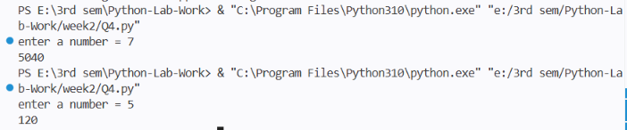
- Write a program to find the sum of the digits of a supplied integer.

Solution:
sum=sum(map(int,input("enter a integer = ")))
print("sum of the digits of a supplied integer = ",sum)
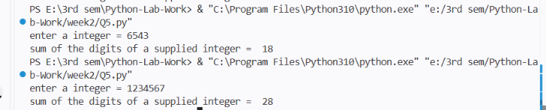
Week #3
- Write a program to print the following pattern using the for loop:
5 4 3 2 1
4 3 2 1
3 2 1
2 1
1

Solution:
# for i in range(5,0,-1):
# for j in range(i,0,-1):
# print(j, end=" ")
# print()

for i in range(5,0,-1):
print(range(i,0,-1))
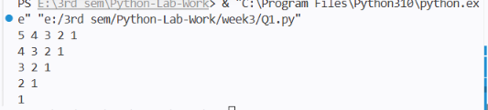
- Write a program to print the following star pattern using the for loop:
*
* *
* * *
* * * *
* * * * *
* * * *
* * *
* *
*
Solution:
for i in range(1, 10):
print()
if i<=5:
for j in range(1, i+1):
print("*", end=" ")
else:
for j in range(10-i):
print("*", end=" ")
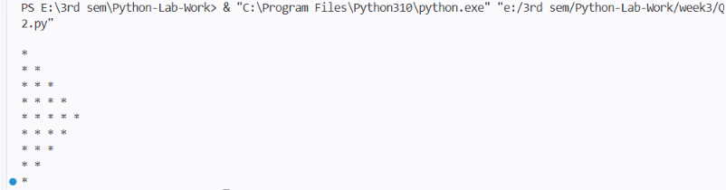

- Write a program to print characters from a string which are present at even index numbers.
Solution:
str="Sumaniya"
for i in range(len(str)):
if i%2==0:
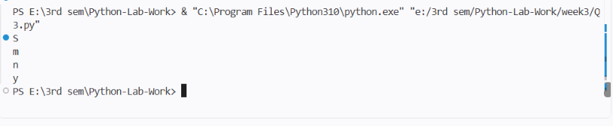
print(str[i])
- Write a program to accept a string from the user and display characters that are present at even index numbers.
Solution:
str= input("enter a string = ")
for i in range(len(str)):
if i%2==0:
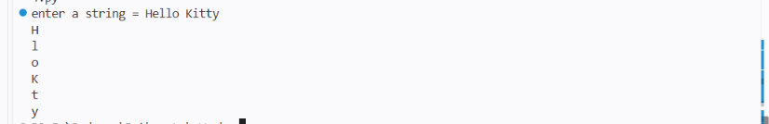
print(str[i])
- Write a program to remove characters from a string starting from the nth position to the last and return a new string. Example: remove_chars(”aligarh”, 3) should output ali.

Solution:
def remove_chars(str,num):return str[:num]
str= input("enter a string = ")
num=int(input("enter the position = "))
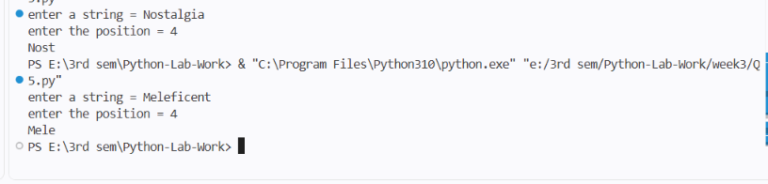
print(remove_chars(str,num))

Week #4
- Write a program to create a function cal_sum_sub() that accepts two variables and calculates addition and subtraction. Also, it must return both addition and subtraction in a single return call.

Solution:
def cal_sum_sub(a,b):
return a+b, a-b

a,b = map(int,input("enter first number = ").split())

print(cal_sum_sub(a,b))

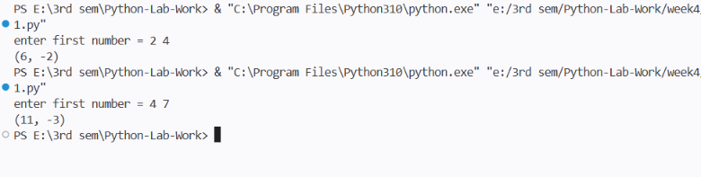

- Write a function to return True if the first and last number of a given list are the same. If the numbers are different, return False.

Solution:
def check_list(lst):
return lst[0]==l[-1]
l= list(map(int,input("enter a list of integer = ").split()))
print(check_list(l))
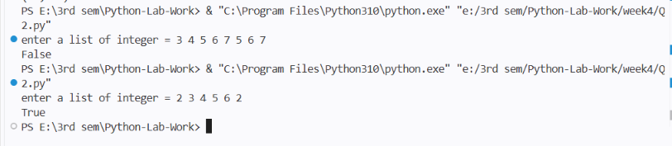
- Given a list of numbers, write a program to turn every item of the list into its square.

Solution:
li= list(map(int,input("enter a list of integer = ").split()))
print(list(map(lambda x:x**2,li)))

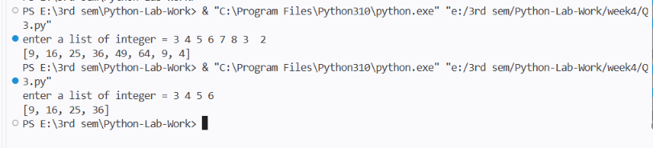

- Given two Python lists, write a program to iterate both lists simultaneously and display items from list1 in original order and items from list 2 in reverse order.

Soultion:
from itertools import zip_longest
l1= [1,2,3,4,5]
l2=[1,2,3,4,5,6,7]
for a,b in zip_longest(l1,reversed(l2),fillvalue=0):
print(a,b)

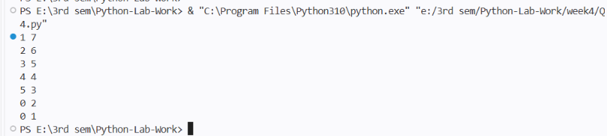
- Write a program to count the number of occurrences of item 50 in the tuple tp1 = (50, 10, 60, 70, 50).
Solution:
tp1=(50,10,60,70,50)
print("tuple = ",tp1)
count=tp1.count(50)
print("number of occurrences = ", count)

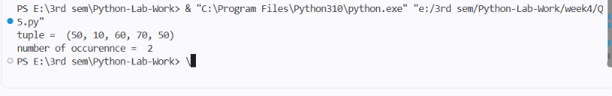

Week #5
- Write a program to generate a 6-digit random secure OTP.

Solution:
import secrets
otp= secrets.randbelow(900000)+100000
print(otp)

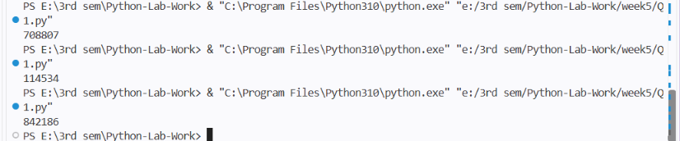

- Write a program to pick a random character from a user-supplied string.

Solution:
import secrets
str= input("enter a string = ")
charac= secrets.choice(str)
print(charac)

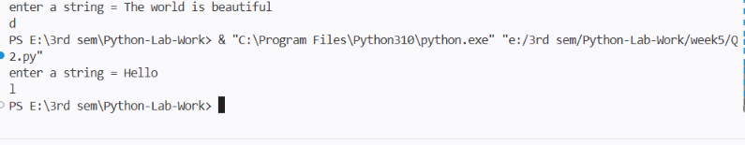

- Write a program to generate a random password that meets the following conditions:
- Password length must be 10 characters long.
- It must contain at least 2 uppercase letters, 1 digit, and 1 special symbol.

Solution:
import random
import string

uppercase = random.choices(string.ascii_uppercase, k=2)
digit = random.choice(string.digits)
special = random.choice("!@#$%^&*")

remaining = random.choices(
string.ascii_letters + string.digits + "!@#$%^&*",
k=6
)
password_list = uppercase + [digit] + [special] + remaining

random.shuffle(password_list)

password = ''.join(password_list)

print("Random Password:", password)

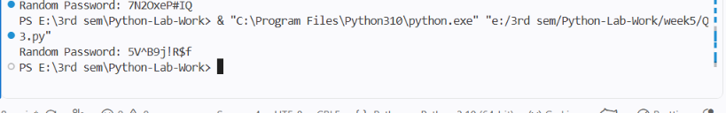

- Given two lists of numbers, write a program to create a new list containing odd numbers from the first list and even numbers from the second list.

Solution:
l1= [1,2,3,4,5,6,5,3]
l2= [2 ,3, 4,8, 7, 6, 5,12,14]
new_l=[]

for i in l1:
if i%2!=0:
new_l.append(i)
for i in l2:
if i%2==0:
new_l.append(i)
print(new_l)

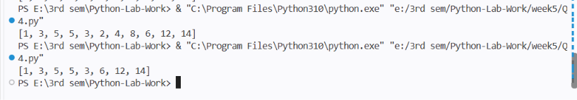

- Write a program to create a numpy array and return an array of odd rows and even columns from the numpy array.
Solution:
import numpy as np
arr = np.array([
[1, 2, 3, 4],
[5, 6, 7, 8],
[9, 10, 11, 12],
[13, 14, 15, 16],
[17, 18, 19, 20]
])
result = arr[::2, 1::2]
print("Original Array:")
print(arr)

print("Odd rows and even columns:")
print(result)

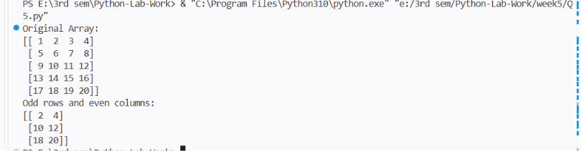

- Write a program to create a numpy array and sort it as per the following cases:
- Case 1: Sort the array by the second row.
- Case 2: Sort the array by the second column.
Solution:
import numpy as np

arr = np.array([
[30, 20, 10],
[3, 1, 2],
[9, 7, 8]
])

print("Original Array:")
print(arr)

# a. Case 1: Sort the array by the second row.

index = np.argsort(arr[1])

result = arr[:, index]

print("Sorted by second row:")
print(result)

# b. Case 2: Sort the array by the second column.
index = np.argsort(arr[:, 1])

result = arr[index]

print("Sorted by second column:")
print(result)

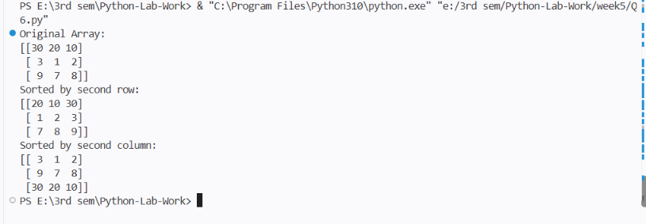

Week #6
- Write a Python program that inputs two tuples and creates a third that contains all elements of the first followed by all elements of the second.
Solution
tup1= tuple(map(int,input("enter numbers for tuple1 = ").split()))
tup2=tuple(map(int,input("enter numbers for tuple2 = ").split()))

tup3= tup1 + tup2
print("contains all element from tup1 to tup2 = ", tup3)
sorted_tup3= sorted(tup3)
print("sorted tuple = ", sorted_tup3)
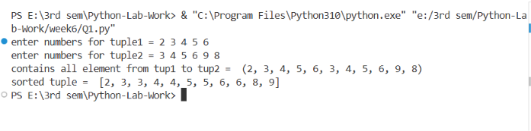
- Write a Python program to create a dictionary with names and phone numbers. Then ask the user for a name and print the corresponding phone number.

Solution
user={
"Sumaniya":4746375862,
"Hadiya":8766375862,
"Rashika":3986375843,}
name=input("input name = ")
for key in user:
if key.casefold()==name.casefold():
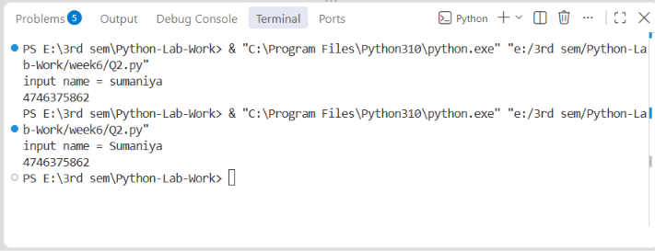
print(user[key])
- Write a Python program to calculate the sum of squares of the first two digits and the last two digits of a 4-digit number, e.g., for 1233, calculate 12^2 + 33^2.

Solution
num= (input("enter a 4 digit number = "))
sum_square= (lambda x,y: int(x)**2 + int(y)**2)(num[0:2], num[2:])
print(sum_square)
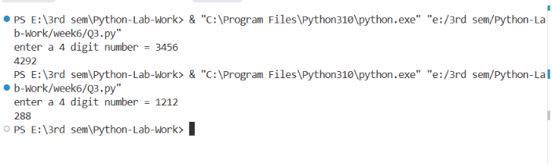

- Write a program that inputs a main string and creates an encrypted string by embedding a short symbol-based string after each character. The program should also decrypt the string.

Solution
# str1= input("Enter the first string: ")
# str2=""
# str3=""
# for i in range(len(str1)):
# str2=str2+str1[i]+"@#"
# print("encrypted : ",str2)

# for i in range(len(str2)):
# if str2[i]!="@" and str2[i]!="#":
# str3=str3+str2[i]
# print("decrypted : ",str3)

str1 = input("Enter the first string: ")

str2 = "@#".join(str1) + "@#"
print("encrypted : ", str2)

str3 = str2.replace("@#", "")
print("decrypted : ", str3)

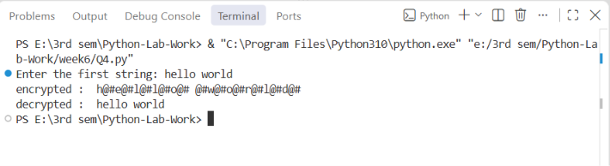

- Write a program to get roll numbers, names, and marks of students and store these details in a file called ”Marks.data”.

Solution

f= open("marks.data", "a")
# f.write("Name\t\tRoll\t\tMarks\n")
num_std =int(input("Enter number of students: "))

for i in range(num_std):
name=input("Enter the name of student = ")
roll_no = input("enter the roll number of student = ")
marks = input("enter the marks of student = ")
f.write(name+"\t\t"+roll_no+"\t\t"+marks+"\n")
f.close()

f= open("marks.data", "r")
data=f.read()
print(data)
f.close()

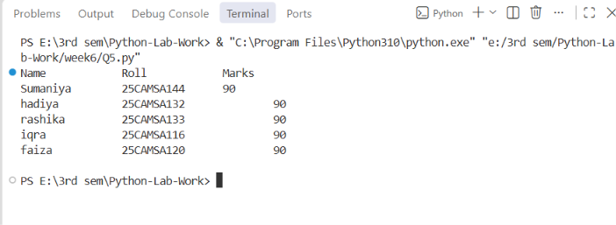
- Write a program to accept a string and display:
- Number of uppercase characters.
- Number of lowercase characters.
- Total number of alphabets.
- Number of digits.

Solution

string = input("Enter a string = ")
uppercase = 0
lowercase = 0
alphabets = 0
digits = 0
symbols = 0
for i in string:
if i.isupper():
uppercase += 1
if i.islower():
lowercase+=1
if i.isalpha():
alphabets+=1
if i.isdigit():
digits+=1
if not i.isalpha() and not i.isdigit():
symbols += 1
print("Number of uppercase letters = ",uppercase)
print("Number of lowercase letters = ",lowercase)
print("Number of alphabets = ",alphabets)
print("Number of digits = ",digits)
print("Number of symbols = ",symbols)
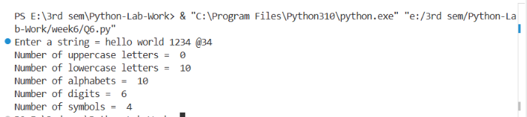

- Create a C program that accepts an IPv4 address and subnet mask in dotted decimal format, and outputs:
- Network ID
- Broadcast Address
- First and Last Host Address
- CIDR notation
- Number of valid hosts
- IP Address Class (A/B/C/D/E)
Solution
#include <stdio.h>
#include <stdint.h>

static void show(const char *label, uint32_t x)
{
printf("%-18s: %u.%u.%u.%u\n", label, x >> 24, (x >> 16) & 255, (x >> 8) & 255, x & 255);
}
int main(void)
{
unsigned a, b, c, d, m, n, o, p;

printf("IP address : "); scanf("%u.%u.%u.%u", &a, &b, &c, &d);
printf("Subnet mask: "); scanf("%u.%u.%u.%u", &m, &n, &o, &p);

uint32_t ip = a << 24 | b << 16 | c << 8 | d;
uint32_t mask = m << 24 | n << 16 | o << 8 | p;
uint32_t net = ip & mask, bc = net | ~mask;
int cidr = __builtin_popcount(mask); /* count the 1 bits */
unsigned long long hosts = cidr >= 31 ? 33ULL - cidr : (1ULL << (32 - cidr)) - 2;
show("Network ID", net);
show("Broadcast Address", bc);
show("First Host", cidr < 31 ? net + 1 : net);
show("Last Host", cidr < 31 ? bc - 1 : bc);
printf("%-18s: /%d\n", "CIDR Notation", cidr);
printf("%-18s: %llu\n", "Valid Hosts", hosts);
printf("%-18s: %c\n", "IP Class", a < 128 ? 'A' : a < 192 ? 'B' : a < 224 ? 'C' : a < 240 ? 'D' : 'E');

return 0;
}

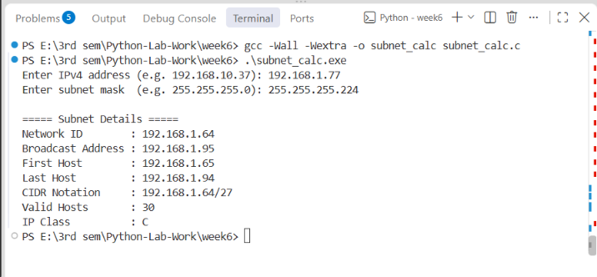

Week #7
- Write a repsort on different types of Linux shells (sh, csh, ksh, bash).
Aim:
To study different types of Linux shells: sh, csh, ksh, and bash.

Theory:
sh (Bourne Shell): The original Unix shell used for executing commands and shell scripts.
csh (C Shell): A shell with syntax similar to the C programming language.
ksh (Korn Shell): An advanced shell based on sh, supporting scripting and command history.
bash (Bourne Again Shell): An improved version of sh and one of the commonly used shells in Linux.
Result:
Different types of Linux shells were studied.

- Copy, move, and remove files using cp, mv, and rm commands.
Aim:
To copy, move, and remove files using cp, mv, and rm commands.
Commands:
cp file1.txt file2.txt
mv file1.txt file2.txt
rm file1.txt

Result:
Files were successfully copied, moved, and removed using cp, mv, and rm commands.
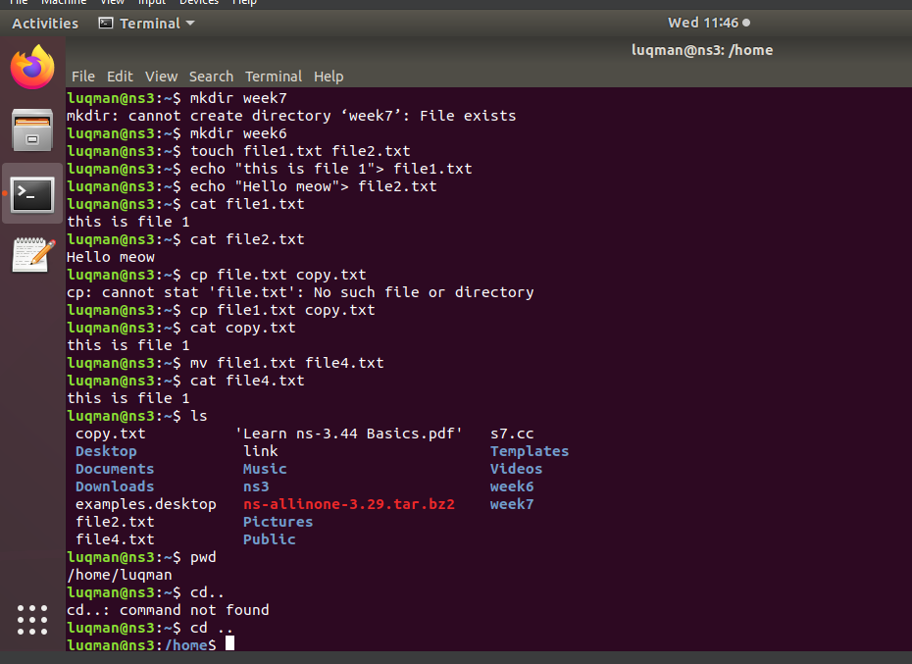

- Create and delete directories using mkdir and rmdir.

mkdir = make folder
rmdir = remove folder
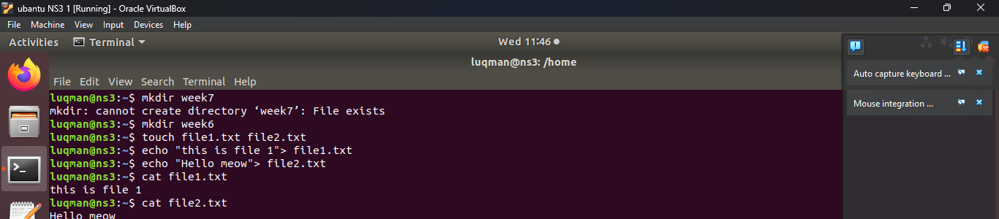
- Change the current working directory using cd and display the present working directory using pwd.
Aim:
To change the current working directory and display the present working directory using cd and pwd commands.
Commands:
pwd
cd Documents
pwd
cd ..
Result:
The current working directory was changed and displayed successfully using cd and pwd commands.
Then paste your terminal screenshot below the Result.

- Consider two files that contain information about Employees and Departments in the following parameters: Employee (Name, EId, Salary, DID), Department (DID, DName, DLocation). Write a Python program to find the average salary of each department.

Solution
employee_file = open("Employee.txt", "r")

employees = employee_file.readlines()
employee_file.close()

salary = {}

for line in employees[1:]:
data = line.strip().split(",")

name = data[0]
eid = data[1]
sal = float(data[2])
did = data[3]

if did not in salary:
salary[did] = []

salary[did].append(sal)

for did in salary:
average = sum(salary[did]) / len(salary[did])
print(did, "Average Salary =", average)
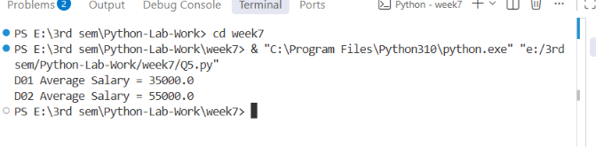

- Consider two files having some lines of statements. Write a Python program to swap content present at middle line of first file with the content of last line of the second file. (Note: First file contains odd numbers of lines of statement)

Solution
# Swap middle line of first file with last line of second file
f1 = open("file1.txt", "r")
lines1 = f1.readlines()
f1.close()

f2 = open("file2.txt", "r")
lines2 = f2.readlines()
f2.close()

middle = len(lines1) // 2

temp = lines1[middle]
lines1[middle] = lines2[-1]
lines2[-1] = temp

f1 = open("file1.txt", "w")
f1.writelines(lines1)
f1.close()

f2 = open("file2.txt", "w")
f2.writelines(lines2)
f2.close()

print("Content swapped successfully")

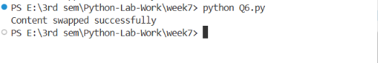
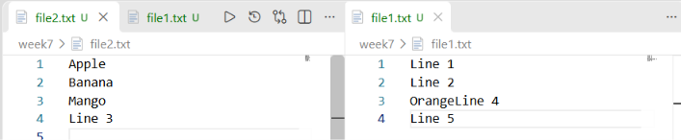

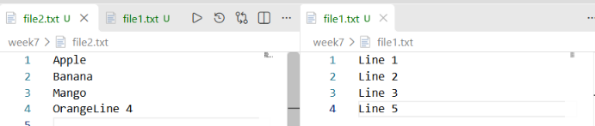

- Simulate a RIP-like behavior using a Python program. Accept a list of directly connected routers with hop counts and simulate RIP updates for 3 rounds. Show how the routing table evolves.

Solution
// Simulate RIP-like behavior for 3 rounds
// command to run
// compile gcc Q7.c -o Q7
// run .\Q7.exe
#include <stdio.h>

int main()
{
int a[3][3] = {
{0, 1, 3},
{1, 0, 999},
{3, 999, 0}
};

int i, j, k, round;

for(round = 1; round <= 3; round++)
{
for(i = 0; i < 3; i++)
{
for(j = 0; j < 3; j++)
{
for(k = 0; k < 3; k++)
{
if(a[i][k] + a[k][j] < a[i][j])
{
a[i][j] = a[i][k] + a[k][j];
}
}
}
}

printf("\nRound %d\n", round);

for(i = 0; i < 3; i++)
{
for(j = 0; j < 3; j++)
{
if(a[i][j] == 999)
printf("INF ");
else
printf("%d ", a[i][j]);
}

printf("\n");
}
}

return 0;
}
